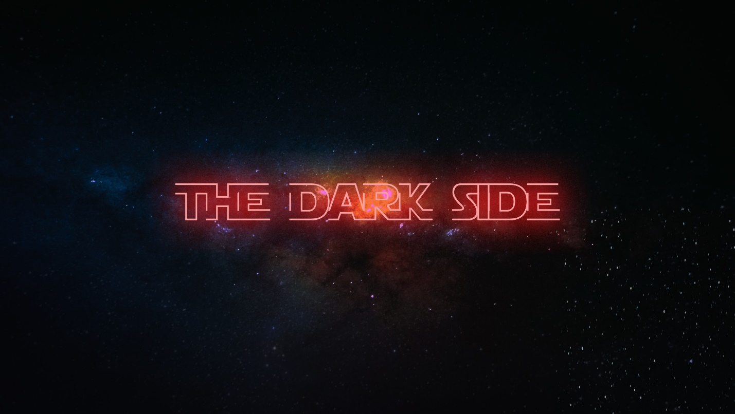

**Week 1 - The Dark Side**

**LIFE/INTRO QUESTIONS (CHOOSE 1 OR 2)**

* What are your biggest fears?
* What would you do if your biggest fear happened to you every day?

**CONNECTION QUESTION**

* Has there ever been a time in your life where you were so scared to do something that you didn't do it and then regretted it later? Explain.

**Sermon in a Sentence**

* Fear is the tool the enemy uses to kill your Faith!

**SCRIPTURE**

* **1 Kings 19: 1-9** Look up verse in your Bible or Bible app.
* What is Jesus saying in this scripture?

**DISCUSSION QUESTIONS**

* Is there a calling from God in your life that you’re ignoring? What is it and why are you ignoring it?
* Have you ever been so scared that you settled for the lesser thing? You were too scared to try out for a sport so you just did it in your own time instead or you were too scared to talk to the new person so you just missed out on an opportunity that could have been great.
* Do you have any fears with being a Christian? Be honest.

**LIFE APPLICATION**

We want students walking away with 1 or 2 things they are going to do SOON to apply what they discussed.

* What are some problems that you face daily and how can you ask God to help relieve some of those problems?
* Do you have the faith to be able to ask God to take away your fears so you can start living the fulfilled life He meant you to have?

**TAKE IT OUT**

* Close small group out with prayer requests.
* After prayer, remind them of THE WEEKEND and any upcoming group events!